**PROJECT TOPIC: SENTIMENT ANALYSIS**

**Group No.: 76**

**Project Group Members:**

1. **Deepali Sharma** (D-78./ 201500210) **2. Anurag Singh** (D-12./ 201500128)

**3. Aman Kumar** (D-05/201500073) **4.** **Nitish Kumar (**G-40/201500454)

**Project Supervisor:** Dr. AKUR RAI, Associate Professor

**About the Project:**

The Twitter Sentiment Analysis project aims to gauge the emotional tone of tweets through natural language processing and machine learning techniques. By leveraging algorithms, the project classifies tweets into categories such as positive, negative, or neutral, providing valuable insights into public opinion and sentiment trends. The analysis involves pre-processing text data, feature extraction, and the training of a sentiment classifier model using a dataset of labeled tweets. The project not only aids businesses in understanding customer perceptions but also contributes to social and political analyses. Real-time processing of tweets allows for dynamic monitoring of sentiments, making it a powerful tool for brand management, market research, and public opinion tracking.

**Motivation:**

The motivation behind Twitter Sentiment Analysis lies in its capacity to unveil the collective text of social media users. By discerning sentiments from vast streams of tweets, this project enables businesses to swiftly adapt to customer feedback, politicians to gauge public opinion, and researchers to comprehend societal trends. Harnessing the power of natural language processing, it empowers decision-makers with timely insights, fostering a responsive and adaptive approach to the ever-evolving landscape of public sentiment on Twitter.

**Project Planning:**

Commencing in September, the Twitter Sentiment Analysis project will kick off with a two-week Research and Learning phase, diving into sentiment analysis algorithms and tools. In the subsequent three weeks, from late September to mid-October, the focus will shift to Data Collection and Pre-processing. Following this, Feature Extraction and Model Selection will occupy weeks 6-9 (mid-October to mid-November), with four weeks dedicated to fine-tuning the model and validation until mid-December. The final three weeks of December will be allocated for Implementation, Integration, Testing.

**\*\*Gantt Chart:\*\***

- **Weeks 1-4 (September):** Research and Learning

- **Weeks 5-8 (October):** Data Collection and Pre-processing

- **Weeks 9-12(November):** Feature Extraction and Model Selection

- **Weeks 13-20 (December to January):** Model Training and Validation

- **Weeks 21-28 (February to March):** Implementation and Integration, Testing.

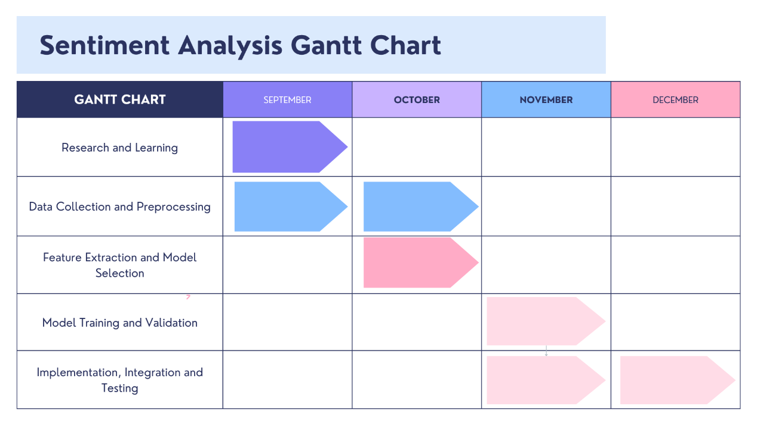

**Tools required:**

* **Hardware Requirements:** Laptop withcorei3 or above processor **4 GB+ RAM**
* **Software Requirements:** Web Browser and Python Machine Learning and Natural language toolkit Libraries.

**Signature of Project Supervisor: ________________**